# INTERVIEW INSIGHT

**A PROJECT REPORT**

**for**

**Project (KCA451)**

**Session (2023-24)**

**Submitted By ASHISH**

**(2200290140040)**

**Submitted in partial fulfilment of the Requirements for the Degree of**

# MASTER OF COMPUTER APPLICATION

**Under the Supervision of Mr. Praveen Kr. Gupta Assistant Professor**



**Submitted to**

**DEPARTMENT OF COMPUTER APPLICATIONS**

**KIET Group of Institutions, Ghaziabad Uttar Pradesh-201206**

**(May 2023)**

**DECLARATION**

I hereby declare that the work presented in the report entitled Interview Insight” was carried out by me. I have not submitted the matter embodied in this report for the award of any other degree or diploma of any other University of Institute. I have given due credit to the original authors/sources for all the words, ideas, diagrams, graphics, computer programs, that are not my original contribution. I have used quotation marks to identify verbatim sentences and give credit to the original authors/sources. I affirm that no portion of my work is plagiarized, and the experiments and results reported in the report are not manipulated. In the event of a complaint of plagiarism and the manipulation of the experiments and results, I shall be fully responsible and answerable.

**Name:** Ashish

**Roll No:** 2200290140040

**CERTIFICATE**

Certified that **Ashish (2200290140040)** has carried out the project work having “**Interview Insight using AI**” for Master of Computer Applications from Dr. A.P.J. Abdul Kalam Technical University (AKTU**)** (formerly UPTU), Technical University, Lucknow under my supervision. The project report embodies original work, and studies are carried out by the students themselves and the contents of the project report do not form the basis for the award of any other degree to the candidate or to anybody else from this or any other University/Institution.

### Date: Ashish (2200290140040)

This is to certify that the above statement made by the candidate is correct to the best of my knowledge.

Date:

### Mr. Praveen Kumar Gupta Dr. Arun Tripathi

**Assistant Professor Head**

### Department of Computer Applications Department of Computer Applications KIET Group of Institutions, Ghaziabad KIET Group of Institutions, Ghaziabad

**Interview Insight Ashish ABSTRACT**

This project presents a web application for real-time emotion analysis in video and audio content. Built with Flask, the application integrates a pre-trained convolutional neural network for video emotion recognition and incorporates Firebase for user authentication and database management. Users can upload video and audio files for immediate analysis, exploring distinct routes for video and audio functionalities.

The video analysis module processes uploaded videos, extracting frames for emotion recognition and providing a breakdown of detected emotions. The audio analysis component designed for audio processing algorithms.

Emphasis is placed on security, error handling, and user authentication. The application's modular design allows for straightforward integration of additional features and improvements, making it adaptable for diverse applications.

This project contributes to the field of affective computing, providing a practical tool for emotion analysis with potential applications in market research, entertainment, and mental health.

**ACKNOWLEDGEMENTS**

Success in life is never attained single-handedly. My deepest gratitude goes to my project supervisor, **Mr. Praveen Kumar Gupta**, Assistant Professor for his guidance, help, and encouragement throughout my project work. Their enlightening ideas, comments, and suggestions.

Words are not enough to express my gratitude to Dr. Arun Kumar Tripathi, Professor and Head, Department of Computer Applications, for his insightful comments and administrative help on various occasions.

Fortunately, I have many understanding friends, who have helped me a lot on many critical conditions.

Finally, my sincere thanks go to my family members and all those who have directly and indirectly provided me with moral support and other kind of help. Without their support, completion of this work would not have been possible in time. They keep my life filled with enjoyment and happiness.

**Ashish (220029014040)**

## TABLE OF CONTENTS

Declaration ii

Certificate iii

Abstract vi

Acknowledgement v

Table of Contents vi

List of Figures vii

1. Introduction 8
   1. Project Description 8
   2. Project Methodology 10
   3. Hardware/Software Used 12
2. Feasibility Study 18
   1. Technical Feasibility 18
   2. Operational Feasibility 21
   3. Economic Feasibility 23
   4. Legal Feasibility 26
3. Design (Input/Output Screenshots) 29
   1. Login/Registration 29
   2. Video/Audio Choice 32
   3. Video/Audio Recording 33
   4. Result 35
4. Limitations 37
5. Future Scope 39
6. Conclusion 42
7. Bibliography 44

**List of Figure**

**Fig No. Figure Name Page No.**

* 1. Home Page 29
  2. Login Page 31
  3. Option Page 32
  4. Recording Page 33
  5. Result Page 36

## CHAPTER 1 INTRODUCTION

### PROJECT DESCRIPTION

The "Multimedia Emotion Analysis Web Application" is a cutting-edge project that introduces an interactive platform for real-time emotion analysis in multimedia content, specifically focusing on video and audio elements. Leveraging Flask as the foundational web framework, the application integrates advanced computer vision techniques and deep learning models to provide users with a seamless and engaging experience.

### Key Features:

1. Video Emotion Recognition:
   * The project incorporates a pre-trained convolutional neural network (CNN) for video emotion recognition.
   * Utilizing OpenCV, frames are extracted from uploaded videos, and the CNN processes these frames to discern emotional states dynamically.
   * The analysis results are presented in a detailed breakdown, showcasing the distribution of detected emotions throughout the video duration.

### Firebase Integration:

* Firebase is integrated to enhance user interactions and security.
* Users can securely log in and sign up, ensuring a personalized experience and the ability to track their analysis history.
* The platform leverages Firebase for efficient database management, ensuring secure storage and retrieval of user data.

### Modular Design and Extensibility:

* + The project is designed with modularity in mind, allowing for easy integration of additional features and improvements.
  + Future expansions, such as audio emotion analysis, are envisioned, providing a foundation for a comprehensive multimedia emotion analysis tool.

### User-Friendly Interface:

The web application features an intuitive and user-friendly interface, making it accessible to a wide range of users.

* + Distinct routes for video and audio analysis enhance the user experience, guiding users through the application's functionalities seamlessly.

### Potential Applications:

1. Market Research: Analyzing customer reactions to advertisements or product demonstrations.
2. Entertainment Industry: Assessing audience engagement with multimedia content.
3. Mental Health: Exploring applications in emotion-aware interfaces for mental health monitoring and support.

The project encapsulates the synergy of computer vision, deep learning, and user-centric design, aiming to provide a valuable tool for emotion analysis in the ever-evolving landscape of multimedia content.

### PROJECT METHODLOGY

The methodology incorporates a combination of computer vision and deep learning techniques to achieve real-time emotion analysis. Here are the detailed steps and considerations involved:

**Video Processing:**

* **OpenCV Utilization:**
  + OpenCV, a powerful and widely used computer vision library, is employed for processing video content.
  + It handles various tasks such as frame extraction, image preprocessing, and video manipulation.
* **Frame Extraction:**
  + Uploaded videos are broken down into individual frames.
  + Each frame is extracted at a specified rate to balance between accuracy and performance.
* **Pre-Processing:**
  + Frames undergo pre-processing steps such as resizing, normalization, and possibly data augmentation.
  + These steps ensure that the frames are in a suitable format for analysis by the CNN.

**Emotion Recognition:**

* **Convolutional Neural Network (CNN):**
  + Each extracted frame is processed through a pre-trained CNN model designed for emotion recognition.
  + The CNN is fine-tuned with a diverse dataset to improve its accuracy in detecting a wide range of emotions.
* **Real-Time Analysis:**
  + The system processes frames on the fly, providing dynamic feedback and real-time emotion analysis.
  + Results are aggregated to present an overall emotional profile of the video.

**Web Framework:**

* **Flask:**
  + Flask is chosen as the web framework for its simplicity, ease of deployment, and flexibility.
  + It supports modular design, making it easy to add or update features without disrupting the existing system.

**User Authentication and Data Management:**

* **Firebase Integration:**
  + Firebase is integrated to manage user authentication, ensuring secure login and sign-up processes.
  + It provides a seamless experience for users, allowing them to track their analysis history and maintain personalized settings.
* **Database Management:**
  + Firebase's real-time database ensures efficient storage and retrieval of user data.
  + It supports secure data transactions, protecting user information from unauthorized access.

**Design and Security Considerations:**

* **Modular Design:**
  + The application is built with a modular architecture, enabling easy integration of new features.
  + This design approach allows for future expansions, such as incorporating audio emotion analysis.
* **Error Handling:**
  + Robust error handling mechanisms are implemented to ensure the application’s reliability.
  + The system anticipates potential issues and handles them gracefully to maintain a smooth user experience.
* **Security Measures:**
  + Emphasis on security is paramount, with measures in place to protect user data and interactions.
  + Secure coding practices and regular security audits are conducted to safeguard the application against vulnerabilities.

**Future Prospects:**

* **Scalability:**
  + The application is designed to scale efficiently, handling increasing amounts of data and user interactions.
  + Future upgrades can be seamlessly integrated due to the modular architecture.
* **Feature Enhancements:**
  + Planned expansions include the addition of audio emotion analysis, enhancing the tool’s comprehensiveness.
  + Continuous improvement through user feedback and technological advancements will keep the application relevant and effective.
* **Versatility:**
  + The adaptable design ensures the tool remains useful across various domains, from market research to mental health applications.

By focusing on these detailed methodological steps, the project aims to deliver a robust, secure, and versatile tool for real-time multimedia emotion analysis.

### HARDWARE / SOFTWARE USED

### Hardware Used :

The hardware components chosen for the "Multimedia Emotion Analysis Web Application" are selected to ensure high performance and reliability for real-time emotion analysis tasks. Below are the detailed explanations of each hardware component used in the project:

**1. Mainframe - Intel Core i9 Ninth Generation**

* Performance:
  + The Intel Core i9 ninth generation processor is known for its high processing power, which is crucial for handling the intensive computations involved in real-time video and audio processing.
  + With multiple cores and high clock speeds, this CPU can efficiently manage the concurrent tasks required by the application, such as video frame extraction, real-time analysis, and data management.
* Suitability:
  + The high performance of the Intel Core i9 ensures that the application runs smoothly without lag, providing users with a seamless experience.

**2. Python on Windows OS**

* Programming Language:
  + Python is the primary programming language used for developing the application due to its extensive libraries and frameworks that support computer vision (OpenCV), deep learning (TensorFlow, Keras), and web development (Flask).
* Operating System:
  + Windows OS is chosen for its compatibility with various hardware components and its support for the necessary development tools and libraries.
* Development Environment:
  + Python on Windows provides a stable and versatile environment for building and deploying the application, ensuring ease of development and deployment.

**3. GPU - Nvidia GTX 1650**

* Graphics Processing Unit:
  + The Nvidia GTX 1650 GPU is integrated to accelerate the deep learning tasks involved in emotion recognition.
  + This GPU is capable of handling parallel processing efficiently, which is essential for the fast processing of video frames and real-time analysis.
* Deep Learning:
  + The GPU's CUDA cores significantly speed up the training and inference processes of the CNN models, making it an ideal choice for this application.

**4. 720p60 Webcam Camera**

* Video Input:
  + A 720p60 webcam is used for capturing video input at 720p resolution and 60 frames per second.
  + This resolution and frame rate provide a good balance between image quality and processing requirements, ensuring that the extracted frames are clear enough for accurate emotion analysis without overwhelming the system.
* Real-Time Capture:
  + The high frame rate of 60 fps allows the system to capture smooth video streams, which is crucial for real-time emotion analysis.

5. **Microphone**

* Audio Input:
  + A microphone is used to capture audio input, which is essential for future expansions that may include audio emotion analysis.
* Voice and Emotion Detection:
  + High-quality audio capture is important for accurately analyzing vocal tones and speech patterns that may indicate different emotional states.

Integration of Hardware with Application

* CPU and GPU Coordination:
  + The Intel Core i9 CPU handles the overall application logic, user interactions, and data management, while the Nvidia GTX 1650 GPU accelerates the deep learning computations.
* Webcam and Microphone:
  + The webcam and microphone provide the necessary input data for the emotion analysis models. The webcam captures video frames that are processed by the CNN, and the microphone captures audio that can be analyzed for vocal emotion cues in future expansions.
* Windows OS and Python:
  + The combination of Python and Windows OS ensures that all hardware components and software libraries work together harmoniously, providing a robust and efficient platform for developing and running the application.

By leveraging these hardware components, the "Multimedia Emotion Analysis Web Application" achieves high performance and accuracy in real-time emotion analysis, offering users a reliable and engaging experience.

### Software Used :

The software components chosen for the "Multimedia Emotion Analysis Web Application" are carefully selected to provide robust, efficient, and scalable solutions for real-time emotion analysis. Below are detailed explanations of each software component used in the project:

**1. Windows OS**

* **Operating System:**
  + Windows OS is the platform on which the application is developed and deployed. It offers compatibility with a wide range of hardware and software tools, ensuring seamless integration and functionality.
* **Development Environment:**
  + The stability and widespread use of Windows OS make it a preferred choice for development environments, providing support for essential libraries and frameworks used in this project.

**2. Python 3**

* **Programming Language:**
  + Python 3 is the primary programming language used for developing the application due to its simplicity, readability, and extensive library support.
* **Libraries and Frameworks:**
  + Python's rich ecosystem includes libraries like OpenCV for computer vision, TensorFlow for deep learning, and Flask for web development, making it an ideal choice for this multifaceted project.

**3. OpenCV**

* **Computer Vision Library:**
  + OpenCV (Open Source Computer Vision Library) is a powerful library used for image and video processing.
* **Frame Extraction and Processing:**
  + It is utilized to extract frames from video, perform image preprocessing, and handle various video manipulation tasks essential for emotion analysis.
* **Efficiency:**
  + OpenCV’s optimized performance ensures that video frames are processed quickly and accurately, which is crucial for real-time analysis.

**4. Firebase**

* **Backend-as-a-Service:**
  + Firebase provides backend services that enhance the application's functionality and user experience.
* **Authentication:**
  + Firebase Authentication is used to manage secure user logins and sign-ups, ensuring that user data and interactions are protected.
* **Database Management:**
  + Firebase Realtime Database efficiently stores and retrieves user data, including analysis history, enabling personalized experiences and seamless data management.

**5. TensorFlow**

* **Deep Learning Framework:**
  + TensorFlow is an open-source deep learning framework developed by Google. It is used to build, train, and deploy the convolutional neural network (CNN) models for emotion recognition.
* **Model Training and Inference:**
  + TensorFlow’s comprehensive tools facilitate the training of deep learning models on large datasets and their deployment for real-time inference, ensuring high accuracy in emotion detection.
* **GPU Acceleration:**
  + TensorFlow leverages GPU acceleration, particularly with Nvidia GPUs, to speed up the training and inference processes, making it suitable for real-time applications.

**6. Visual Studio Code**

* **Integrated Development Environment (IDE):**
  + Visual Studio Code (VS Code) is a popular, lightweight, and powerful IDE used for writing and debugging code.
* **Extensions and Tools:**
  + It supports a wide range of extensions and tools that enhance productivity, such as Python support, linting, debugging capabilities, and version control integration.
* **User Experience:**
  + VS Code’s user-friendly interface and powerful features make it an excellent choice for managing the complex codebase of the project.

**7. Flask**

* **Web Framework:**
  + Flask is a lightweight web framework for Python, used to develop the web application component of the project.
* **Modularity and Simplicity:**
  + Flask’s simplicity and modularity make it easy to develop, deploy, and maintain the web application. It allows for clear organization of code and straightforward implementation of new features.
* **API Development:**
  + Flask is also used to create APIs for integrating various components of the application, such as the frontend interface with the backend emotion analysis engine.

**Integration of Software with Application**

* **Windows OS:**
  + Provides a stable and compatible environment for all the software tools used in the project.
* **Python 3:**
  + Serves as the core programming language, facilitating the integration of different libraries and frameworks to build a cohesive application.
* **OpenCV and TensorFlow:**
  + Work together to handle the computer vision and deep learning aspects of the project, ensuring efficient video processing and accurate emotion recognition.
* **Firebase:**
  + Manages user authentication and data storage, enhancing security and user experience.
* **Visual Studio Code:**
  + Supports the development process through its robust features and tools, aiding in writing, debugging, and maintaining the application’s codebase.
* **Flask:**
  + Powers the web application, enabling user interactions, routing, and API development for seamless integration of the various functionalities.

By leveraging these software components, the "Multimedia Emotion Analysis Web Application" ensures robust performance, high accuracy, and a seamless user experience in real-time emotion analysis.

## CHAPTER 2

**Feasibility Study**

### Technical Feasibility:

**Objective:**

Determine the practicality and viability of implementing the proposed multimedia emotion analysis web application from a technical standpoint.

### Assessment:

* + - Technology Stack Suitability:

The selected technologies, including Flask, OpenCV, Keras, and Firebase, are well- established and widely used in web development, computer vision, and deep learning.

These technologies offer robust features, scalability, and compatibility with various devices and operating systems.

* + - Modularity and Adaptability:

The modular design of the application supports future enhancements, allowing for seamless integration of additional features such as audio analysis.

Git version control ensures effective collaboration and maintenance, enhancing the adaptability of the project over time.

* + - Technical Challenges Mitigation:

Real-time video processing challenges are addressed through optimized use of OpenCV, ensuring efficient frame extraction and preprocessing.

Integration of the pre-trained CNN using Keras is streamlined, mitigating potential challenges associated with deep learning model incorporation.

* + - User-Centric Benefits:

Firebase integration provides secure user authentication and database management, contributing to a personalized and user-friendly environment.

The technical feasibility study indicates that the chosen technologies and development approach are suitable for successful implementation.

### Operational Feasibility:

The operational feasibility study evaluates the practicality and efficiency of implementing and maintaining the "Multimedia Emotion Analysis Web Application." Here are the key points to consider:

**1. Development and Deployment**

* Development Environment:
  + Utilize Windows OS as the primary development platform for its compatibility and stability.
  + Employ Python 3 due to its extensive library support and ease of integration with other tools and frameworks.
* Integrated Development Environment (IDE):
  + Use Visual Studio Code (VS Code) for development, providing robust features like linting, debugging, and version control integration.
* Web Framework:
  + Implement Flask as the web framework for its simplicity and modularity, allowing for easy updates and maintenance.

**2. Hardware Utilization**

* Mainframe and Processing Power:
  + Leverage Intel Core i9 ninth generation for high processing power to handle complex computations and real-time processing tasks.
  + Use Nvidia GTX 1650 GPU to accelerate deep learning model training and inference, ensuring efficient real-time analysis.
* Input Devices:
  + Integrate a 720p60 webcam for high-quality video input, ensuring clear frames for accurate emotion analysis.
  + Utilize a microphone for capturing audio input, supporting future expansions into audio emotion analysis.

**3. Software and Tools**

* Computer Vision and Deep Learning:
  + Use OpenCV for video processing tasks such as frame extraction and preprocessing.
  + Employ TensorFlow for building, training, and deploying the CNN models for emotion recognition.
* Backend Services:
  + Integrate Firebase for user authentication, ensuring secure login and sign-up processes.
  + Use Firebase Realtime Database for efficient and secure data storage and retrieval, maintaining user data and analysis history.

4. User Interface and Experience

* Web Application Design:
  + Design a user-friendly interface that is intuitive and accessible, catering to users with varying levels of technical expertise.
  + Provide distinct routes for video and audio analysis, guiding users seamlessly through the application's functionalities.
* Real-Time Feedback:
  + Ensure the application provides real-time feedback by processing video frames dynamically, offering continuous insights into the emotional content.

**5. Operational Workflow**

* Frame Extraction and Processing:
  + Extract frames from uploaded videos using OpenCV, ensuring frames are processed at an optimal rate to balance performance and accuracy.
  + Feed the extracted frames into the pre-trained CNN for emotion recognition, aggregating results to present a comprehensive emotional profile.
* User Data Management:
  + Securely manage user data and analysis history using Firebase, ensuring personalized user experiences and efficient data handling.
* Modular Design:
  + Build the application with a modular architecture, allowing for easy integration of new features and updates without disrupting existing functionalities.

**6. Security and Error Handling**

* Security Measures:
  + Implement robust security measures to protect user data, including encryption, secure authentication, and regular security audits.
  + Ensure compliance with data protection regulations such as GDPR, CCPA, and other relevant laws.
* Error Handling:
  + Integrate comprehensive error handling mechanisms to ensure application reliability and resilience.
  + Anticipate potential issues and implement solutions to handle them gracefully, maintaining a smooth user experience.

**7. Maintenance and Support**

* Ongoing Maintenance:
  + Plan for regular updates and maintenance to keep the application running smoothly and securely.
  + Monitor performance and user feedback to identify areas for improvement and implement necessary changes.
* User Support:
  + Provide user support channels to address queries and issues, ensuring users have access to help when needed.

**8. Future Expansions**

* Scalability:
  + Design the application to scale efficiently, handling increasing amounts of data and user interactions without compromising performance.
* Feature Enhancements:
  + Plan for future enhancements, such as adding audio emotion analysis, to expand the application's capabilities.
  + Continuously improve the application based on user feedback and advancements in technology.

By considering these operational feasibility points, the "Multimedia Emotion Analysis Web Application" can be effectively implemented and maintained, ensuring high performance, user satisfaction, and scalability. This approach supports the application’s long-term success and adaptability to future needs.

**2.3 Economic Feasibility Study**

The economic feasibility study evaluates the cost-effectiveness and financial sustainability of the "Multimedia Emotion Analysis Web Application." Here are the key points to consider:

**1. Initial Development Costs**

* Hardware Expenses:
  + Purchase of Intel Core i9 ninth generation mainframe.
  + Acquisition of Nvidia GTX 1650 GPU for deep learning acceleration.
  + Procurement of a 720p60 webcam and a microphone for capturing video and audio input.
* Software Licensing:
  + While many software components like Python, OpenCV, and TensorFlow are open-source and free, there may be costs associated with premium features or enterprise support for Firebase.
* Development Tools:
  + Visual Studio Code is free, but additional extensions or tools might incur costs.
* Human Resources:
  + Hiring developers and data scientists for initial development.
  + Potential outsourcing costs for specialized tasks.

**2. Operational Costs**

* Server and Hosting:
  + Monthly expenses for hosting the web application on cloud platforms like AWS, Google Cloud, or Azure.
  + Costs associated with scaling infrastructure based on user demand.
* Maintenance and Updates:
  + Ongoing costs for maintaining the application, fixing bugs, and implementing updates.
  + Regular security audits and updates to ensure data protection.
* User Support:
  + Expenses for providing user support and handling inquiries, including staffing a support team.

**3. Data Storage and Management**

* Firebase Costs:
  + Firebase charges based on the usage of its authentication and real-time database services.
  + Costs scale with the number of users and the amount of data stored and retrieved.
* Data Backup:
  + Costs associated with ensuring regular data backups and disaster recovery solutions.

**4. Marketing and Outreach**

* Initial Marketing Campaign:
  + Budget for marketing efforts to promote the application upon launch, including digital marketing, social media ads, and collaborations.
* Ongoing Marketing:
  + Continuous investment in marketing to attract new users and retain existing ones.
  + Potential costs for SEO optimization and content marketing.

**5. Revenue Generation**

* Subscription Model:
  + Introducing a subscription-based pricing model for accessing premium features.
  + Offering tiered subscriptions based on usage, analysis capabilities, and support levels.
* Freemium Model:
  + Providing basic features for free while charging for advanced functionalities.
  + Monetizing through in-app purchases for additional analysis credits or enhanced services.
* Enterprise Solutions:
  + Offering customized solutions for businesses, especially in sectors like market research, entertainment, and mental health.
  + Charging businesses for bulk usage or integration with their existing systems.

**6. Cost-Benefit Analysis**

* Initial Investment vs. Long-Term Gains:
  + Comparing the upfront development and operational costs with projected long-term revenue.
  + Estimating break-even points and potential profitability over time.
* User Growth Projections:
  + Estimating the growth rate of the user base and its impact on revenue.
  + Analyzing market trends and potential demand for emotion analysis tools.

**7. Risk Management**

* Financial Risks:
  + Assessing risks related to funding shortages, cost overruns, or slower-than-expected user adoption.
  + Preparing contingency plans and reserve funds to mitigate financial risks.
* Market Risks:
  + Evaluating the competitive landscape and potential threats from existing or emerging competitors.
  + Adapting business strategies based on market feedback and changing user preferences.

**8. Funding and Investment**

* Initial Funding:
  + Securing funding through investors, grants, or loans to cover initial development costs.
* Revenue Reinvestment:
  + Reinvesting early revenue into scaling and improving the application.

By considering these economic feasibility points, the "Multimedia Emotion Analysis Web Application" can ensure financial sustainability and profitability. This approach helps in making informed decisions about investment, cost management, and revenue generation, supporting the long-term success of the application.

**Top of Form**

**2.4 Legal Feasibility Study**

Assessing the legal feasibility of the "Multimedia Emotion Analysis Web Application" involves evaluating various legal considerations to ensure compliance with relevant laws and regulations. Here are the key points to consider:

**1. Data Privacy and Protection**

* **Compliance with GDPR:**
  + Ensure that the application complies with the General Data Protection Regulation (GDPR) if it processes data from users in the European Union. This includes obtaining explicit consent from users for data collection and processing, and providing options to access, rectify, or delete their data.
* **CCPA Compliance:**
  + For users in California, comply with the California Consumer Privacy Act (CCPA). This includes transparency in data usage, providing users with rights to access and delete their personal data, and ensuring secure handling of data.
* **Other Regional Laws:**
  + Adhere to other regional data protection laws, such as Brazil’s LGPD, Canada’s PIPEDA, and similar regulations in other jurisdictions.

**2. User Consent and Transparency**

* **Clear Privacy Policy:**
  + Develop a clear and comprehensive privacy policy detailing what data is collected, how it is used, and the measures taken to protect it. This policy should be easily accessible to users.
* **User Consent:**
  + Implement mechanisms to obtain explicit consent from users before collecting and processing their data. Users should be informed about the purpose of data collection and how their data will be used.

**3. Intellectual Property Rights**

* **Use of Pre-Trained Models:**
  + Verify that the pre-trained CNN models and any other third-party software or libraries used (e.g., TensorFlow, OpenCV) are properly licensed. Ensure that their use complies with the terms of their licenses.
* **Content Ownership:**
  + Ensure users retain ownership of the multimedia content they upload. Clearly state this in the terms of service.

**4. Data Security**

* **Security Measures:**
  + Implement robust security measures to protect user data from unauthorized access, breaches, and cyber threats. This includes encryption, secure authentication methods, and regular security audits.
* **Compliance with Standards:**
  + Adhere to industry standards and best practices for data security, such as ISO/IEC 27001 and NIST Cybersecurity Framework.

**5. User Generated Content (UGC)**

* **Content Moderation:**
  + Implement content moderation policies to handle inappropriate or harmful content. Establish guidelines for acceptable use and provide mechanisms for users to report violations.
* **Liability for UGC:**
  + Include disclaimers in the terms of service to limit liability for user-generated content, making it clear that users are responsible for the content they upload.

**6. Third-Party Integrations**

* **Firebase Integration:**
  + Ensure that Firebase’s services used for authentication and data storage comply with relevant data protection laws. Review Firebase’s privacy policy and terms of service to understand their obligations and responsibilities.
* **API Usage:**
  + If integrating with third-party APIs, ensure that the usage complies with their terms of service and privacy policies.

**7. Regulatory Compliance**

* **Industry-Specific Regulations:**
  + Identify and comply with any industry-specific regulations that may apply, such as HIPAA for healthcare-related applications or COPPA for applications involving children.
* **Continuous Monitoring:**
  + Regularly monitor changes in relevant laws and regulations to ensure ongoing compliance. Update policies and practices as necessary to remain compliant.

**8. Terms of Service and User Agreements**

* **Comprehensive Terms:**
  + Develop comprehensive terms of service outlining the rights and responsibilities of both the users and the application. Include clauses on data usage, content ownership, liability, and dispute resolution.
* **User Acceptance:**
  + Ensure that users accept the terms of service and privacy policy before using the application. Provide clear instructions on how to access these documents.

By addressing these legal feasibility points, the "Multimedia Emotion Analysis Web Application" can ensure compliance with relevant laws and regulations, protecting both the application and its users. This approach minimizes legal risks and fosters user trust.

# CHAPTER 3

## Design

### Login/Registration:

### Figure 3.1: Home Page

* Prioritization of Simplicity, Security, and User Engagement: The design focuses on these core aspects to ensure an effective user experience.

* Clean and Intuitive Layout: The login page features a straightforward design that facilitates a seamless login experience.
* Prominently Displayed Login Form: The form captures user attention with clearly marked fields for email and password entry.
* Cohesive Color Scheme and Branding Elements: These design choices enhance the visual appeal and ensure brand consistency.
* Encrypted Password Fields: Ensures secure entry of sensitive information.
* Firebase Authentication: Provides a robust and reliable method for user login.
* Clear and Concise Error Messages: Strategically placed to guide users through any authentication issues they may encounter.
* Consistency with Application Theme: The login page integrates seamlessly with the overall design of the application, providing a consistent user journey.
* Emphasis on Functionality and User Experience: The design balances practicality and aesthetics to foster a positive and secure login interaction.

Overall, these elements contribute to an engaging, secure, and user-friendly login experience for users of the multimedia emotion analysis web application.

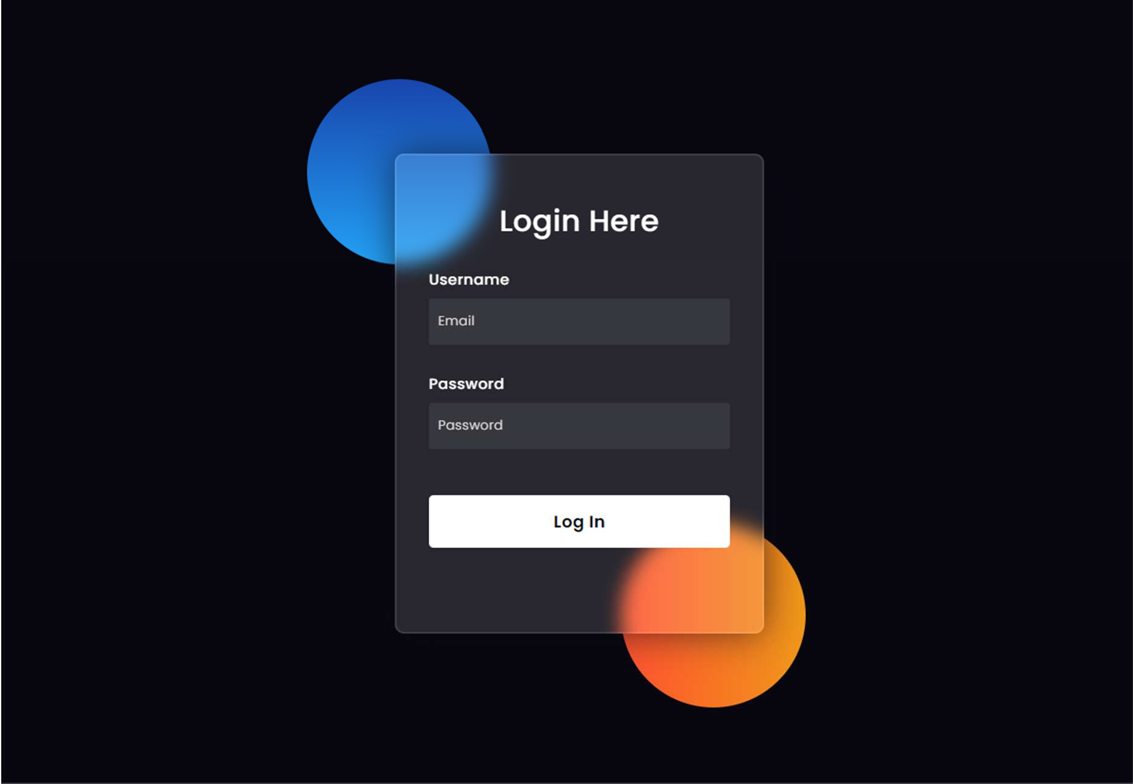

Fig 3.2: Login Page

* Focus on Simplicity, Security, and User Engagement:
  + The design emphasizes these key aspects to ensure an effective login experience.
* Clean and Intuitive Layout:
  + The interface is designed to be user-friendly, providing a seamless login experience.
* Prominent and Inviting Login Form:
  + The form captures attention with clearly marked fields for email and password entry.
* Thoughtful Use of Color Schemes and Branding Elements:
  + Enhances the visual appeal and ensures a cohesive design.
* Enhanced Security Measures:
  + Encrypted Password Fields: Ensures secure entry of sensitive information.
  + Firebase Authentication: Provides a robust and reliable login process.
* Clear and Concise Error Messages:
  + Strategically placed to assist users with authentication issues.
* Seamless Integration with Application Theme:
  + The login page aligns with the overall design of the application, ensuring a consistent and aesthetically pleasing user journey.
* Emphasis on Functionality and User Experience:
  + The design balances practicality and aesthetics to foster a positive and secure login interaction.

Overall, these elements contribute to a user-friendly, secure, and visually appealing login page for users of the multimedia emotion analysis web application.

### Video/Audio Choice:

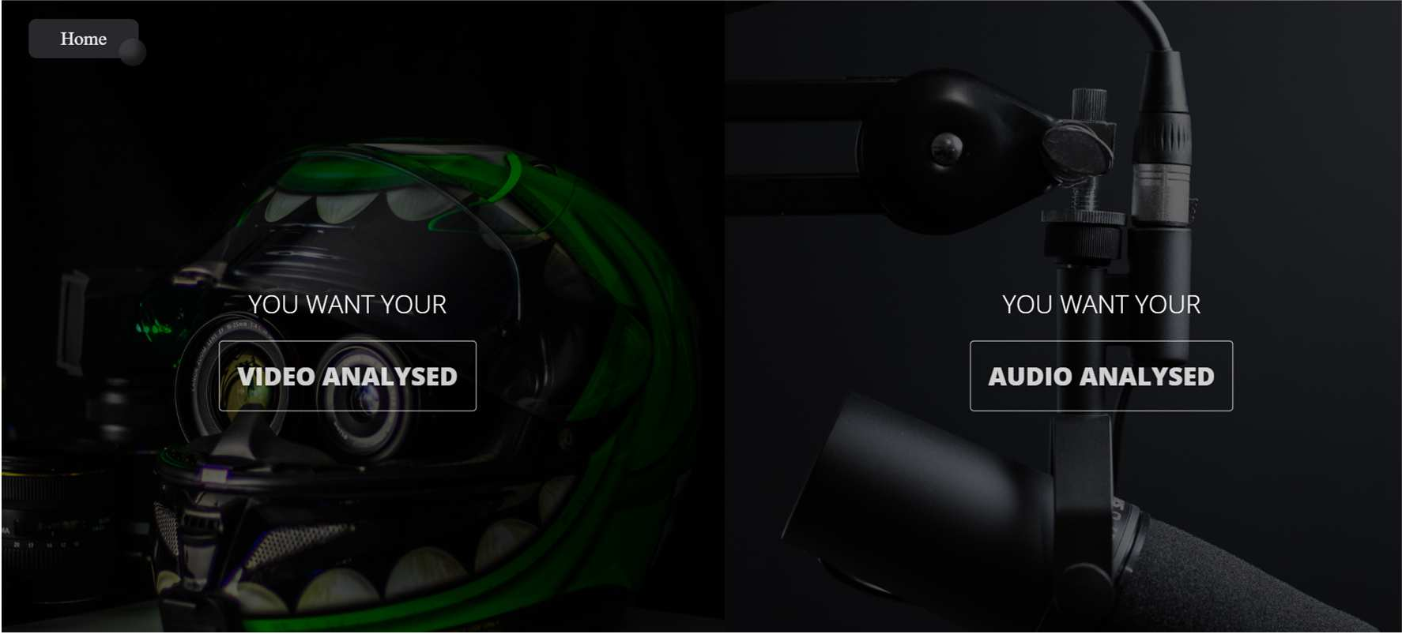

Fig 3.3: Option Page

* Visually Striking Split-Pane Layout:
  + Engages users and provides an intuitive entry point to the application.
* Contrasting Backgrounds:
  + Each background is associated with a specific analysis type (video or audio).
  + Enhances visual appeal and provides a clear visual distinction between functionalities.
* Interactive Hover Effects:
  + Each pane reveals additional information when hovered over.
  + Encourages user interaction and exploration.
* Incorporation of Branded Buttons:
  + Ensures seamless navigation between video and audio analysis.
* Balance Between Aesthetics and Functionality:
  + Contributes to a dynamic and user-centric login page experience.

Overall, these design elements create an engaging, visually appealing, and functional choice page for users of the multimedia emotion analysis web application.

### Video/Audio Recording:

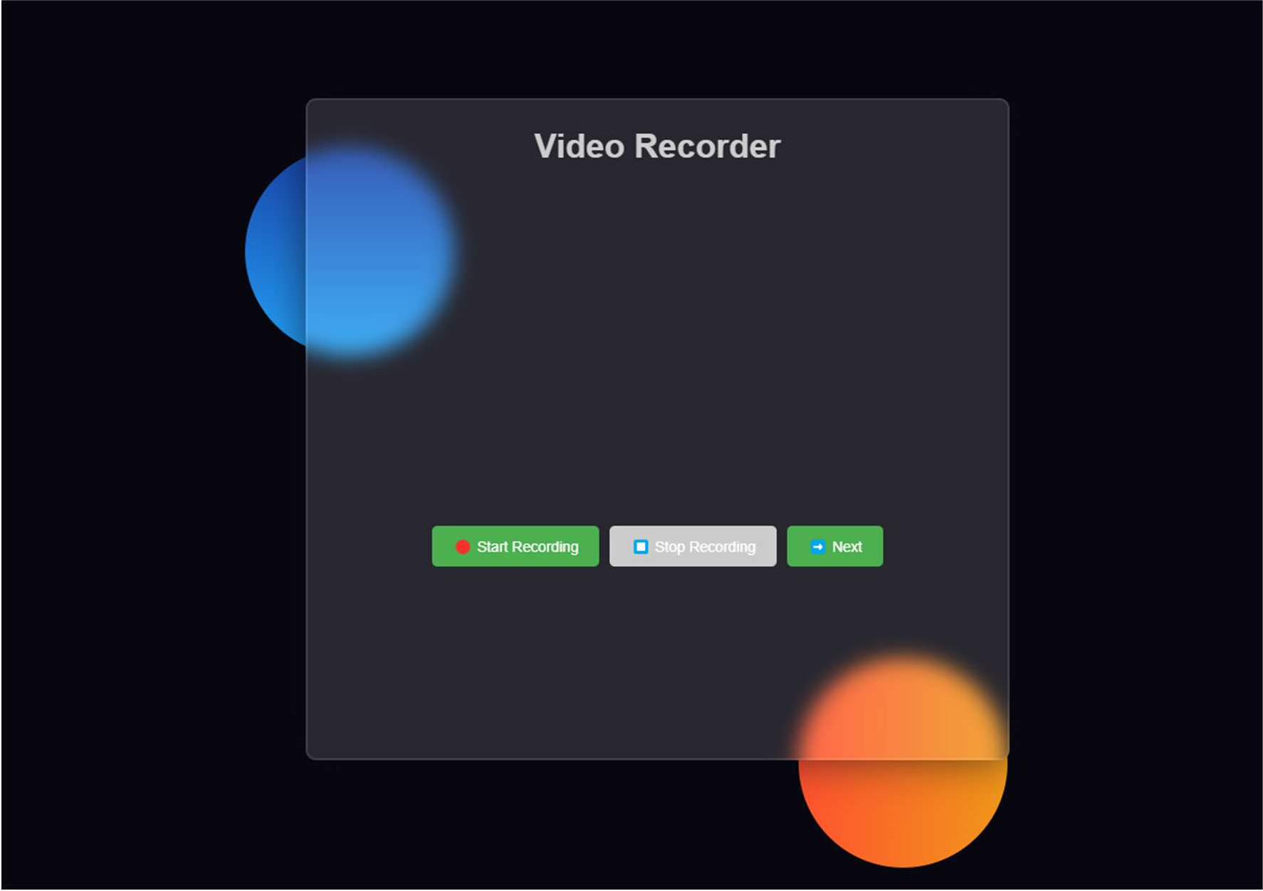

Fig 3.4: Recording Page

* + - Simplicity and Functionality:
      * Designed to be easy-to-use, allowing users to record videos directly from their web browsers.
    - Sleek Container with Backdrop Filter:
      * Provides a modern aesthetic and a clean interface.
    - Dynamic Background Animation:
      * Adds visual appeal and enhances user engagement.
    - Intuitive Recording Controls:
      * "Start Recording" and "Stop Recording" buttons for seamless operation.
      * Recorded videos are available for download with a clear link.
    - Responsive Design Elements:
      * Ensures a user-friendly experience across various devices.
    - User Engagement:
      * Background animation and modern design elements improve overall user interaction.

Overall, the design prioritizes a clean, straightforward recording experience, making it an effective tool for capturing videos effortlessly.

### Result:

Fig 3.5: Result Page

* Visually Appealing and Informative Dashboard:
  + Displays emotion analysis results of recorded videos.
* Modern and Sleek Aesthetic:
  + Utilizes Poppins font.
  + Features a dark color scheme.
* Emotion Data Representation:
  + Expressive emojis.
  + Percentage values.
  + Personalized feedback.
* Elegantly Styled Cards:
  + Cards with backdrop filters for depth.
  + Insightful suggestions based on emotion analysis.
* Enhanced User Interaction:
  + Strategically placed logout and navigation buttons.
* Dynamic Background Animation:
  + Adds sophistication to the user experience.

Overall, the design creates a well-crafted interface that balances visual appeal with functionality for presenting video analysis results.

# CHAPTER 4

## Limitations

While the "Interview Insight" project appears well-designed and functional, it may have certain limitations. Here are some potential limitations:

* + 1. **Emotion Accuracy:** The accuracy of emotion analysis algorithms may vary based on factors such as lighting conditions, video quality, and individual differences in facial expressions. These factors can impact the system's ability to accurately identify and interpret subtle emotions. For instance, poor lighting can obscure facial features, while high video compression can degrade image quality, both of which can reduce the effectiveness of the emotion detection algorithms. Additionally, individual differences in how people express emotions, such as through micro-expressions, can pose a challenge to the system's accuracy.
    2. **Limited Emotion Categories:** The system's emotion analysis might be limited to a predefined set of categories (e.g., Angry, Disgust, Fear, Happy, Sad, Surprise, Neutral). This limitation could result in an oversimplification of human emotions, which are inherently complex and nuanced. For example, mixed emotions or subtle variations like nostalgia, contempt, or boredom might not be accurately captured, potentially leading to incomplete or misleading analysis results.
    3. **Cultural Sensitivity:** The project may not account for cultural variations in facial expressions and emotional cues. Emotion interpretation can vary significantly across cultures, and the system might not be universally applicable. For example, certain facial expressions considered polite or respectful in one culture might be interpreted differently in another. This lack of cultural sensitivity could lead to inaccuracies in emotion recognition and interpretation for users from diverse backgrounds.
    4. **Real-time Processing:** Depending on the video length and complexity, real-time processing might be challenging, leading to delays in providing analysis results. This delay could impact the user experience, especially if immediate feedback is crucial, such as during a live interview or real-time assessment. Processing high-resolution videos or those with a lot of movement might require significant computational resources, potentially causing lag or delays that frustrate users.
    5. **Audio Analysis Scope:** If the project includes audio analysis, the scope might be limited to basic features like tone of voice and volume. More sophisticated aspects of speech analysis, such as sentiment analysis or natural language understanding, might not be fully explored. This could limit the depth of insights the system can provide, as it might miss out on detecting subtleties in spoken language, such as sarcasm, irony, or emotional undertones that are not directly tied to tone or volume.
    6. **Security and Privacy Concerns:** The project should address potential security and privacy concerns, especially if it involves recording and analyzing personal videos. Ensuring the confidentiality and secure storage of user data is essential to maintaining user trust and complying with data protection regulations. Potential risks include unauthorized access to sensitive information, data breaches, and misuse of personal data. Implementing strong encryption, secure data storage, and strict access controls are necessary measures to mitigate these risks.

Addressing these limitations through continuous testing, user feedback, and updates could contribute to the ongoing improvement and success of the "Interview Insight" project. Regularly updating the algorithms, expanding emotion categories, incorporating cultural sensitivity training, enhancing real-time processing capabilities, broadening the scope of audio analysis, and ensuring robust security measures are critical steps towards overcoming these challenges.

## CHAPTER 5

**Future Scope**

The "Interview Insight" project has a promising foundation, and there are several avenues for future development and enhancement:

1. **Advanced Emotion Recognition:** Incorporate more advanced machine learning models and algorithms to enhance the accuracy and granularity of emotion recognition. This could involve detecting a wider range of emotions and subtle facial expressions.
2. **Multimodal Analysis:** Expand the analysis to include multiple modalities, such as audio and speech analysis. Combining facial expressions with voice tone and content could provide a more comprehensive understanding of the interviewee's emotional state and communication style.
3. **Personalized Feedback:** Develop a feature that offers personalized feedback based on the analysis results. This could include tailored suggestions for improvement in communication skills, emotional expression, or interview performance.
4. **Interview Performance Metrics:** Integrate metrics to assess overall interview performance, including non-verbal cues. This could involve evaluating factors such as eye contact, body language, and speech patterns to provide a holistic view of communication effectiveness.
5. **Real-time Feedback:** Implement real-time feedback during video recording to assist users in adjusting their expressions and communication style on the fly. This feature could enhance the learning experience and immediate self-correction.
6. **Expanded Cultural Sensitivity:** Improve the system's ability to recognize and adapt to cultural differences in facial expressions and communication norms. This could involve training the model on a more diverse dataset representing various cultural contexts.
7. **Interactive Interview Simulations:** Transform the platform into an interactive interview simulation tool. Users could practice interviews with virtual interviewers and receive detailed feedback on both verbal and non-verbal communication.
8. **Integration with Job Boards and Platforms:**

Partner with job boards and online recruitment platforms to offer "Interview Insight" as an integrated feature. This would allow users to practice for specific job interviews by analyzing sample interview questions and scenarios relevant to the applied position.

1. **Industry-Specific Training Modules:**

Develop industry-specific training modules that tailor interview preparation to the unique communication styles and technical requirements of different professions. This could involve incorporating industry jargon, technical interview questions, and simulations specific to each field.

1. **Collaboration Features:**

Implement functionalities that enable users to share interview practices with friends, mentors, or career coaches. This would allow for peer feedback and broaden the range of insights users can receive.

1. **VR Integration (Future):**

As VR technology advances, explore the possibility of integrating virtual reality simulations. This could create even more immersive and realistic interview practice environments, allowing users to experience the pressure and dynamics of a real interview setting.

1. **AI-powered Mock Interview Partners:**

Develop AI-powered mock interview partners who can engage in dynamic and personalized conversations. These virtual interviewers could adapt their responses and questions based on the user's communication style and interview answers, mimicking a real interview experience.

1. **Stress Management Techniques:**

Incorporate stress management techniques and relaxation exercises into the platform. This could help users manage interview anxiety and improve their overall performance under pressure.

1. **Success Story Sharing:**

Create a platform section where users can share their interview success stories. This could motivate others and provide valuable insights into real-world interview experiences.

By exploring these future scopes, "Interview Insight" can evolve into a sophisticated and versatile tool that goes beyond emotion analysis, providing valuable insights and support for individuals aiming to enhance their interview and communication skill.

## CHAPTER 6

**Conclusion**

In conclusion, "Interview Insight" presents a compelling solution for individuals seeking to refine their interview and communication skills. The integration of facial expression analysis provides a unique perspective, allowing users to gain insights into their emotional expressions during interviews. The current design showcases an intuitive user interface, coupled with real-time feedback and personalized suggestions based on emotion recognition.

However, like any project, "Interview Insight" has its limitations. The accuracy of emotion recognition may be influenced by factors such as lighting conditions, diverse facial expressions, and cultural variations. Addressing these limitations and continuously refining the underlying algorithms will be crucial for the project's success.

Looking ahead, the future scope of "Interview Insight" is promising. Opportunities for advanced emotion recognition, multimodal analysis, personalized feedback, and integration with learning platforms open avenues for growth. The potential to expand into interactive interview simulations, collaboration features, and integration with AI- driven recruitment reflects a commitment to providing users with a comprehensive and valuable tool for professional development.

To ensure sustained success, the project should prioritize user feedback, security, and privacy considerations. Incorporating diverse datasets for training models and embracing emerging technologies will contribute to the project's adaptability and relevance in a dynamic landscape.

"Interview Insight" holds the potential to become an indispensable tool for job seekers, students, and professionals alike. By addressing its limitations and embracing future opportunities, the project can evolve into a sophisticated platform that not only analyzes emotions but also guides users toward effective communication and interview success.

# CHAPTER 7

## Bibliography

### [1]- A parameter-less algorithm for tensor co-clustering.

Elena Battaglia & Ruggero G. Pensa Volume 112

Pages 385–427 https://link.springer.com/article/10.1007/s10994-021-06002-w

### [2]- Model-free inverse reinforcement learning with multi-intention, unlabeled, and overlapping demonstrations.

Ariyan Bighashdel, Pavol Jancura & Gijs Dubbelman Volume 110

Pages 425-430 https://link.springer.com/article/10.1007/s10994-022-06273-x

### [3]- Constrained regret minimization for multi-criterion multi-armed bandits.

Anmol Kagrecha, Jayakrishnan Nair & Krishna Jagannathan Volume 112

Pages 431-458 https://link.springer.com/article/10.1007/s10994-022-06291-9

[4]- WINdowed TENsor decomposition for Densification Event Detection in timeevolving networks

Sofia Fernandes, Hadi Fanaee-T, João Gama, Leo Tišljarić & Tomislav Šmuc Volume 112

Pages 459-481 https://link.springer.com/article/10.1007/s10994-021-05979-8

[5]- Learning multi-agent coordination through connectivity-driven communication.

Emanuele Pesce & Giovanni Montana Volume 112

Pages 483-514

https://link.springer.com/article/10.1007/s10994-022-06286-6 37 [6]- Feed-Forward Neural-Symbolic Learner.

Daniel Cunnington, Mark Law, Jorge Lobo & Alessandra Russo Volume 112

Pages 515-569 https://link.springer.com/article/10.1007/s10994-022-06278-6

[7]- Efficient learning of large sets of locally optimal classification rules. Van Quoc Phuong Huynh, Johannes Fürnkranz & Florian Beck

Volume 112

Pages 571-610 https://link.springer.com/article/10.1007/s10994-022-06290-w [8]- Circular-symmetric correlation layer.

Bahar Azari & Deniz Erdoğmuş Volume 112

Pages 611-631 https://link.springer.com/article/10.1007/s10994-022-06288-4

[9]- Robust federated learning under statistical heterogeneity via hessian-weighted aggregation.

Adnan Ahmad, Wei Luo & Antonio Robles-Kelly Volume 112

Pages 633-654 https://link.springer.com/article/10.1007/s10994-022-06292-8

[10]- Hierarchically structured task-agnostic continual learning. Heinke Hihn & Daniel A. Braun

Volume 112

Pages 655-686

https://link.springer.com/article/10.1007/s10994-022-06283-9 38

[11]- Relational data embeddings for feature enrichment with background information.

Alexis Cvetkov-Iliev, Alexandre Allauzen & Gaël Varoquaux Volume 112

Pages 687-720 https://link.springer.com/article/10.1007/s10994-022-06277-7

[12]- Embedding to reference t-SNE space addresses batch effects in single-cell classification.

Pavlin G. Poličar, Martin Stražar & Blaž Zupan Volume 112

Pages 721-740 https://link.springer.com/article/10.1007/s10994-021-06043-1

[13]- Time and space complexity of deterministic and nondeterministic decision trees. Mikhail Moshkov

Volume 91

Pages 45-74

https://link.springer.com/article/10.1007/s10472-022-09814-1 [14]- Neural networks in Fréchet spaces.

Fred Espen Benth, Nils Detering & Luca Galimberti Volume 91

Pages 75-103 https://link.springer.com/article/10.1007/s10472-022-09824-z